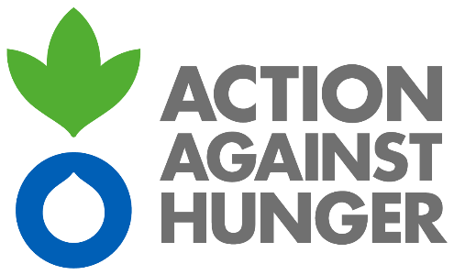

TERMS OF REFERENCE
EXTERNAL SERVICE
Website Development
Funded under the project:
Promoting inclusive and participatory local development in Akhmeta Municipality

Supported by:

European Union

Implemented by:

Action Against Hunger
& Kakheti Regional Development Foundation

Location:
Tbilisi & Akhmeta, Georgia
1. background ON THE PROJECT
Action Against Hunger - Spain, as part of the Action Against Hunger (AAH) International network, is an international non-governmental, private, apolitical, non-confessional and non-profit organisation that fights hunger and its root causes worldwide. It has been operating in the South Caucasus region since 1994 and its current programmes focus on the following areas: Food Security, Livelihoods, Agriculture, Economic and Rural Development.

With the support of the European Neighbourhood Programme for Agriculture and Rural Development (ENPARD), Action Against Hunger is implementing the project “Promoting inclusive and participatory local development in Akhmeta Municipality” in partnership with the Kakheti Regional Development Foundation (KRDF). The project aims to improve the socio-economic integration of disadvantaged rural communities in Georgia and contribute to poverty reduction through an inclusive and community-led approach to rural development to improve the quality of life and economic conditions in Akhmeta Municipality. The principal mechanism of this approach is the Local Action Group, which is a public-private partnership of local community members that represent a broad cross section of different groups and sectors within the municipality. To provide information to the general public on the work of the Local Action Group and the project opportunities, a purpose-built website will be created. Therefore, AAH is looking to contract a Service Provider to support the website development and maintenance process.
2. GENERAL OBjective OF ASSIGNMENT

The contracted Service Provider will be required to create (design, develop, test, implement and maintain) a web platform within the designated timeline.

3. Scope of work

- To design a website with the following features and options
- Interactive, comprehensive and user-friendly web design (including search engine, events calendar, multi-language options, map generation, blog, Google analytics etc.);
- Reasonable site load-time;
- Can be used on a wide variety of different browsers;
- Optimized for tablet/smartphones and for areas with low connectivity;
- Support social network integration;
- Installation of a submission page to allow users to upload and submit relevant documents that will be managed and authorized through the admin area by the project team.
- To support project staff with content management including the ability to create, remove, edit and publish content
- To support the development of site statistics/management reports to allow authorized users with information such as user registration, site usage, key interests/topics being discussed within the collaborative spaces and other relevant statistical data.
- Provide remote maintenance support for a period of 6 months

4. KEY DELIVERABLES & TIMEFRAME

- A fully operational website to be designed and delivered by the 15th July 2019.
- Remote support to be provided until 15th January 2020.

5. QualificationS & ExperIEnce Required

- Significant experience of innovative and creative web design
- Good understanding of end users’ needs and requirements and to match with adequate technical solutions
- Strong track record in website design, security, administration and maintenance
- Value for money proposition

6. GeNERAL CONDITIONS

Required start date: June 5th, 2019

Duration of work: 40 days for website development and 6 months for remote support

Location of work: Tbilisi (and occasionally Akhmeta – transport will be provided)

Fees: The total amount for fees to be negotiated based on the financial proposition and experience of the Service Provider.

Payment: 70% to be paid on completion of website development and 30% at end of period of remote support.

Rights: The ownership of the site will belong to Action Against Hunger and the donor exclusively. Site information will not be shared by the Service Provider to anybody prior to the delivery of the final product to Action Against Hunger.

Other: Any materials / IT equipment required to carry out the assigned service must be provided by the Service Provider

7. APPLICATION PROCESS

- Interested applicants should send a mail expressing their interest to apply along with a company CV listing previous experience that includes a list (or links) to previous websites that have been designed and developed by the Service Provider;
- The mail should also contain a financial proposition with the gross rate for remuneration (in GEL).
- Applications to be sent to the Action Against Hunger email address: procurement@sc.acfspain.org with the subject “Website Development” no later than May 27th, 2019

